Pokhara University

Level: Bachelor | Semester – Fall | Year : 2008
Programme: BE |  | Full Marks : 100
Course: Filter Design |  | Time : 3hrs.

Candidates are required to give their answers in their own words as far as practicable.
The figures in the margin indicate full marks.

Attempt all the questions.

1. | - Describe different types of filters based on attenuation curves.  - Define scaling and derive the expression to determine the new value of the circuit elements I frequency, magnitude and both frequency and magnitude scaling. | 8  7
2. | - Obtain the transfer function of a low pass filter satisfying following criteria such that the magnitude response has equiripple behaviour in pass band.  Pass band attenuation = 1dB  Stop band attenuation = 20dB  Pass band edge frequency = 1000 Hz  Stop band edge frequency = 2000 Hz  - You are provided with the following specification:  α_{max} = 0.01db in 15kf30k]  α_{min} = 45db in f 10k and f35k  Sketch (i) gain plot, and (ii) attenuation plot | 7  8
3. | - What is the importance of frequency transformation in filter design? Explain low pass to high pass transformation.  - Realize the following asymptotic magnitude response. Also find the element values in practical range if required. | 7  8
4. | - Derive the transfer function for Two Thomas Biquad second order circuit.  - Define the terms sensitivity of centre frequency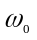 and quality factor Q of the following circuit with respect to each circuit elements.  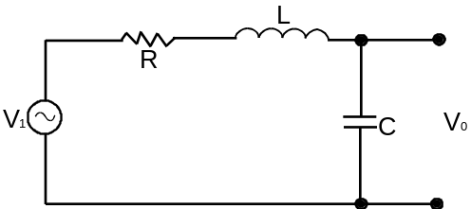 | 7  8
5. | - Realize the following circuit with active simulation of grounded inductors:  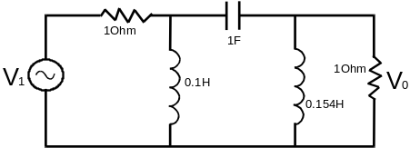  - What is Leap Frog simulation? Why is it needed? Explain with the help of a suitable example. | 8  7
6. | - Write down the procedure to design the higher order filters.  - What is the importance of RC - CR transformation on techniques? Explain using Sallen Key Biquad Circuit.  - What are the properties of lossless ladded Network? Explain Single and Double terminated LC ladder circuit with an example. | 5  5  5
7. | Write short notes on (Any Two)  - Transmission coefficient and reflection coefficients.  - Generalized impedance converter (GIC)  - Equalization procedures in filter design  - Sequencing of filter blocks | 5×2

